Severe Weather Phenomena

***C:\Users\jcrocker\AppData\Local\Microsoft\Windows\Temporary Internet Files\Content.IE5\R408SW7R\MC900231014[1].wmf***There are several severe weather storms. The conditions have different effects and there are safety concerns associated with each. The three types of severe weather include:

***Thunderstorm***

A thunderstorm is a severe storm with lightning, thunder, heavy rain and strong winds. A few effects of thunderstorms may be: heavy rains can cause flooding; lightning can cause fires; strong winds can blow over trees or power lines. Safety concerns related to a thunderstorm are: stay inside, out and away from water, do NOT stand near or under trees if you are stuck outside.

***C:\Users\jcrocker\AppData\Local\Microsoft\Windows\Temporary Internet Files\Content.IE5\NX6N15AN\MC900335182[1].wmf***

***Tornado***

A tornado is a small, funnel-shaped cloud that comes down from a storm cloud with winds spinning at VERY high speeds. A few effects of tornados may be: high winds can tear apart buildings or destroy everything in its path. Safety concerns related to a tornado are: find a safe place away from windows, if you can’t find shelter inside, lie flat in a ditch or low place. Do NOT stay in a car.

***Hurricane***

A hurricane is a large storm that forms over warm ocean water with very strong winds that blow in a circular pattern around the center, or eye, of the storm. A few effects of hurricanes may be: high winds can blow over trees, power lines, and buildings; heavy rains can cause flooding; storm waves on the ocean can come in at the beach and damage coastal areas. Safety concerns related to a hurricane 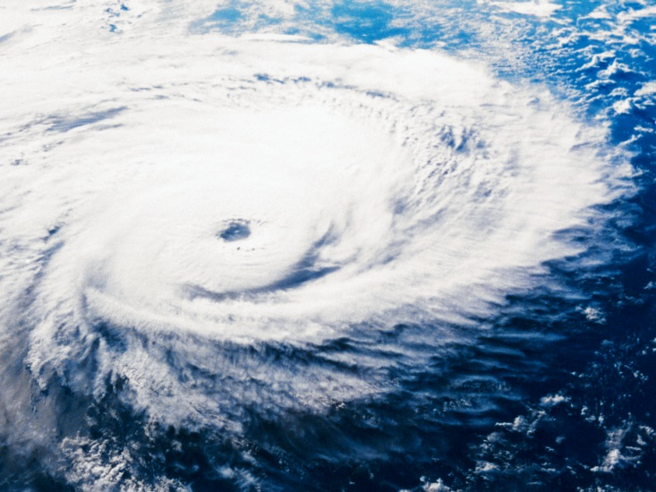are: board up windows in your house, stay away from windows, and evacuate further inland.